Congratulations!
the
30th Anniversary of
Knuckeys Lagoon Community

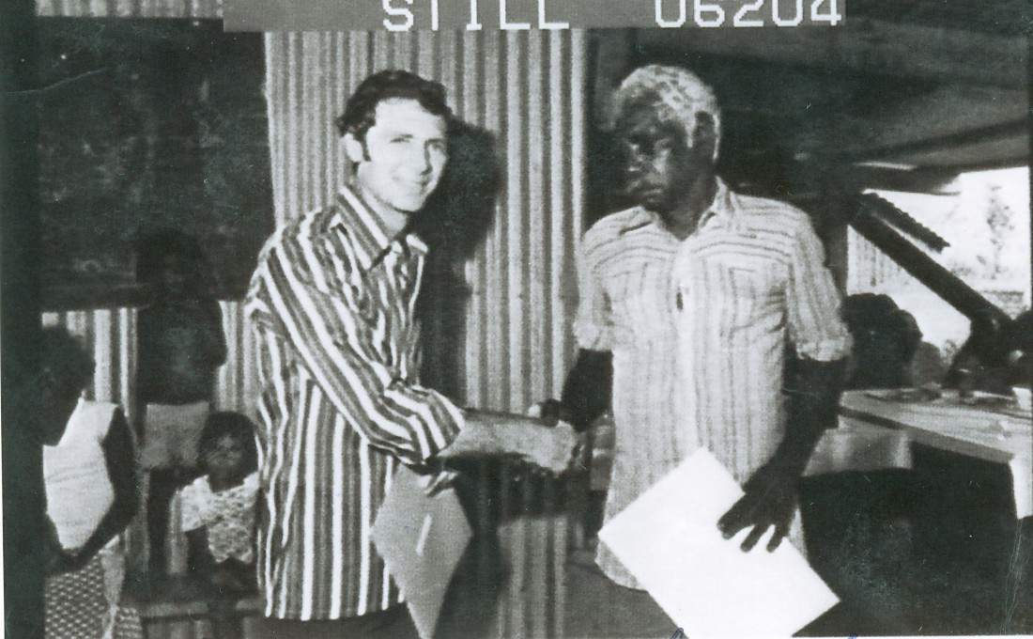
Above: Minister for Lands and Housing Marshall Perron hands over the lease to Knuckeys Lagoon on 14th December, 1979. (Photo 06204 from NT Library)

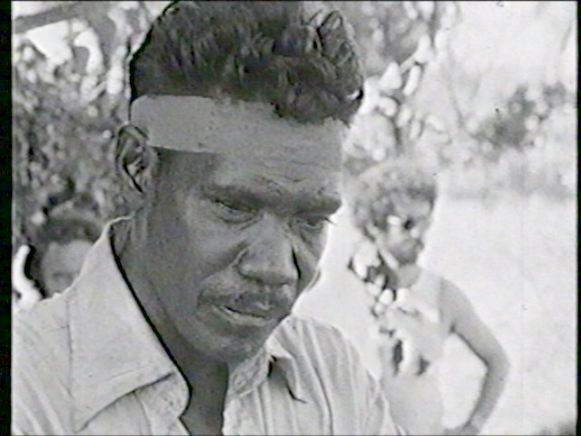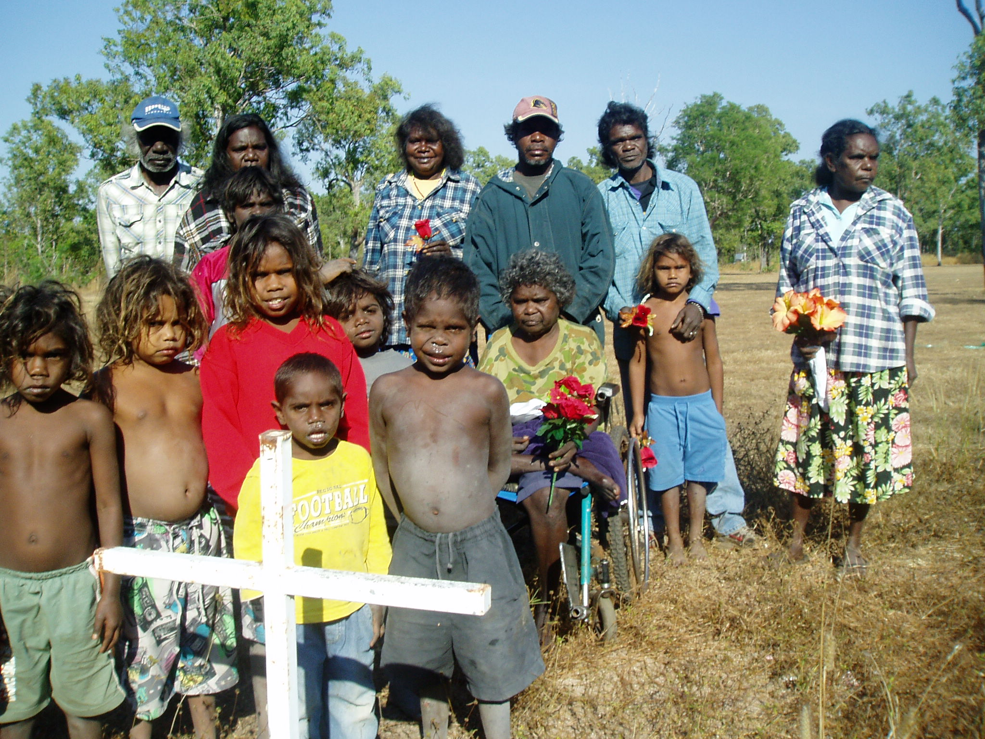
Remember the brave people who fought for the land!

READ THEIR STORY IN BILL DAY’S BOOK, BUNJI: a story of the Gwalwa Daraniki Movement.

